**Steps followed to complete the Project**

**Steps followed to clean and transform data**

1. **Import the data from all available Excel files**

* Imported all required files into **Power Query**.

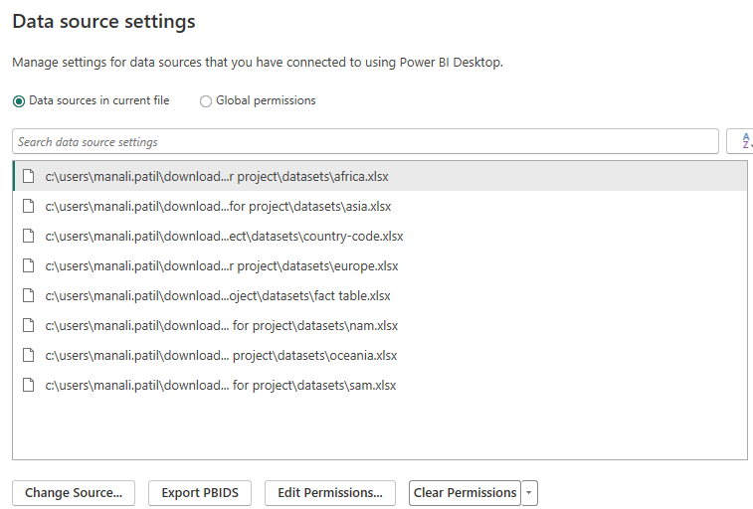

1. **Data transformation:**

* Created a **separate** table as “Zomato Global” by appending all city tables.
* Required **City** names are corrected i.e. Sí£o Paulo, ÛÁstanbul, Brasí_lia to São Paulo, Istanbul, Brasília respectively.

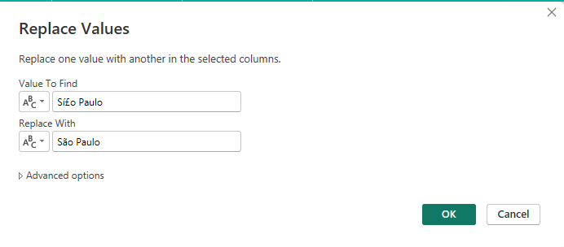

1. **Remove any columns that aren't being used.**

* **Removed** columns which are not being used.



1. **Create two columns to display the Restaurant Name and Restaurant Address.**

* Split “**Restaurant Name,Address**” into “**Restaurant Name**” and "**Restaurant Address**” **A screenshot of a computer

  Description automatically generated**

1. **Make a separate table for the list of the cuisines that each restaurant serves.**

* Created a **separate table** as “Cuisines” with Restaurant ID and Cuisines.
* **Split** Cuisines column by **delimiter with row**.

1. **As it's a dimension table, the Country-Code table must only include unique and non-blank values.**

* In Country_Code table, **Duplicate** and **Null** values removed.

* Remaining tables are **hided** from Power Query to import required data only which are visible in **Italic** now.

* Applied and closed the Power Query Editor.
* From **Model View Tab**, relevant **Relationships** between tables created.

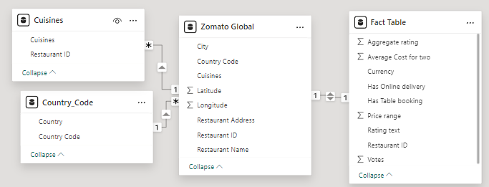

**Steps followed to use DAX Query**

1. **Add a Rating color column in an appropriate table with the data rows.**

* Created a new column for Rating color with below DAX Query.  
  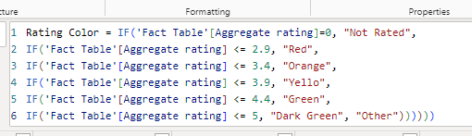

1. **Create the following measures in the appropriate tables.**
2. **Restaurant count**

New Measure is created as “**Restaurant Count**” with below DAX Query.  
  
**Restaurant Count = COUNT('Zomato Global'[Restaurant ID])**



1. **Average cost**New Measure is created as “**Average Cost”** with below DAX Query.  
     
   **Average Cost = AVERAGE('Fact Table'[Average Cost for two])**  
   
2. **Average rating**New Measure is created as “**Average Rating”** with below DAX Query.  
     
   **Average Rating = AVERAGE('Fact Table'[Aggregate rating])  
   **
3. **Cuisine count**New Measure is created as “**Cuisine Count”** with below DAX Query.  
     
   **Cuisine Count = DISTINCT(Cuisines[Cuisines])  
   **

**3) Create a new column in the Country Code table and name it “Continent” and create the values using the below-mentioned convention**

**Note: The mapping is continent - country, for example ''Africa – South Africa''**

Created a new column in Country_Code table as “**Continent**” with using below **SWITCH** DAX Query.  
  
**Continent = SWITCH(Country_Code[Country Code], 189, "Africa", 215, "Europe", 37,"NAM", 216, "NAM", 30,"SAM", 14, "Oceania", 148, "Oceania", "Asia")**



**Steps followed to Prepare Dashboard**

1. **KPIs**Created 4 different KPI Cards for **Total Restaurant, Count of Cuisines, Average Cost** and **Average rating.**
2. **MAP**

Created a map with Country Value and Total Restaurant as tooltip.

1. **Tree Map**Created a Tree Map Values with Total Restaurant and Category as Cuisines.  
   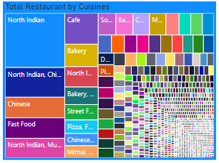 A screenshot of a computer

   Description automatically generated
2. **Slicer**
   1. Created 2 slicers with dropdown. One for Country and one for Continent.   
      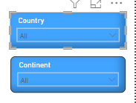
   2. Created one more slicer for City with Vertical
3. **Stacked Bar Chart  
    a.** Created a Stacked Bar Chart for Total Restaurant by City.  
    **A bar graph with red and blue text

   Description automatically generated**

**b.** Created a Stacked Bar Chart for Total Restaurant by Rating Color.  
 Arranged Bar color as per their name assigned.

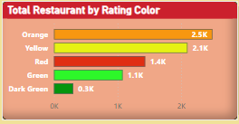

1. **Pie Charts**Created 2 Pie charts, one for Online Delivery status and one for Table Booking.  
   **A comparison of pie charts

   Description automatically generated**
2. **Insert Images**Inserted 2 logo images from Insert Image option.
3. Arranged all the graphs in a proper manner to have great visual understanding.
4. Color and Font Formatting done for all graphs and arranged accordingly.
5. Final view of interactive Dashboard.  
     
   A screenshot of a menu

   Description automatically generated
6. **Result**  
   With the help of this Dashboard one can find total number of Restaurant as per the City, Country, Continent.  
   Also, We can check Restaurant count by Average rating, By the Online Delivery mode, Table booking.  
   We can get Cuisines details from Tree Map.  
   Different KPIs created like, Total Restaurant Count, Average Cost, Count of Cuisines, and Average rating.

* As a result, we can see Maximum Restaurant is from Delhi City with count 5473.
* Major Average rating is between 3 to 3.4.
* 74% order was for Online Delivery.
* 89% people booked table.
* Around 936 Restaurant with North Indian Cuisines with highest number.
* Different filters can be selected as per requirement.